SEC Form 3
FORM 3 | UNITED STATES SECURITIES AND EXCHANGE COMMISSION  Washington, D.C. 20549  INITIAL STATEMENT OF BENEFICIAL OWNERSHIP OF SECURITIES  Filed pursuant to Section 16(a) of the Securities Exchange Act of 1934  or Section 30(h) of the Investment Company Act of 1940
  OMB APPROVAL
  OMB Number: | 3235-0104
  Estimated average burden
  hours per response: | 0.5
1. Name and Address of Reporting Person*  (Street) | 2. Date of Event Requiring Statement (Month/Day/Year)  06/29/2026 | 3. Issuer Name and Ticker or Trading Symbol  APPFOLIO INC [ APPF ]  Foreign Trading Symbol
  Yang Michael MiQi
  (Last) | (First) | (Middle)
  70 CASTILIAN DRIVE
  SANTA BARBARA | CA | 93117
  (City) | (State) | (Zip)
 |  | 4. Relationship of Reporting Person(s) to Issuer  (Check all applicable) | 5. If Amendment, Date of Original Filed (Month/Day/Year)  07/01/2026
   | Director |  | 10% Owner
   | Officer (give title below) |  | Other (specify below)
6. Individual or Joint/Group Filing (Check Applicable Line)
Form filed by One Reporting Person
Form filed by More than One Reporting Person

Table I - Non-Derivative Securities Beneficially Owned
1. Title of Security (Instr. 4) | 2. Amount of Securities Beneficially Owned (Instr. 4) | 3. Ownership Form: Direct (D) or Indirect (I) (Instr. 5) | 4. Nature of Indirect Beneficial Ownership (Instr. 5)
Class A Common Stock | 1,559(1) | D
Table II - Derivative Securities Beneficially Owned
(e.g., puts, calls, warrants, options, convertible securities)
1. Title of Derivative Security (Instr. 4) | 2. Date Exercisable and Expiration Date (Month/Day/Year) |  | 3. Title and Amount of Securities Underlying Derivative Security (Instr. 4) |  | 4. Conversion or Exercise Price of Derivative Security | 5. Ownership Form: Direct (D) or Indirect (I) (Instr. 5) | 6. Nature of Indirect Beneficial Ownership (Instr. 5)
1. Title of Derivative Security (Instr. 4) | Date Exercisable | Expiration Date | Title | Amount or Number of Shares | 4. Conversion or Exercise Price of Derivative Security | 5. Ownership Form: Direct (D) or Indirect (I) (Instr. 5) | 6. Nature of Indirect Beneficial Ownership (Instr. 5)
Explanation of Responses:
1. The Reporting Person holds 1,559 shares of Class A Common Stock in a Roth IRA.
Remarks:
This Form 3/A amends the Form 3 filed on July 1, 2026, which reported Mr. Yang's initial holdings using the Issuer's CIK number while pending receipt of Mr. Yang's new filer CIK codes. This Form 3/A has been filed using Mr. Yang's CIK codes and reflects him as the Reporting Owner. No changes have been made or are being reported with respect to Mr. Yang's beneficial ownership of Issuer securities.
 | /s/ Heather Peterson, as Attorney-in-Fact for Michael MiQi Yang | 08/18/2026
 | ** Signature of Reporting Person | Date
Reminder: Report on a separate line for each class of securities beneficially owned directly or indirectly.
* If the form is filed by more than one reporting person, see Instruction 5 (b)(v).
** Intentional misstatements or omissions of facts constitute Federal Criminal Violations See 18 U.S.C. 1001 and 15 U.S.C. 78ff(a).
Note: File three copies of this Form, one of which must be manually signed. If space is insufficient, see Instruction 6 for procedure.
Persons who respond to the collection of information contained in this form are not required to respond unless the form displays a currently valid OMB Number.
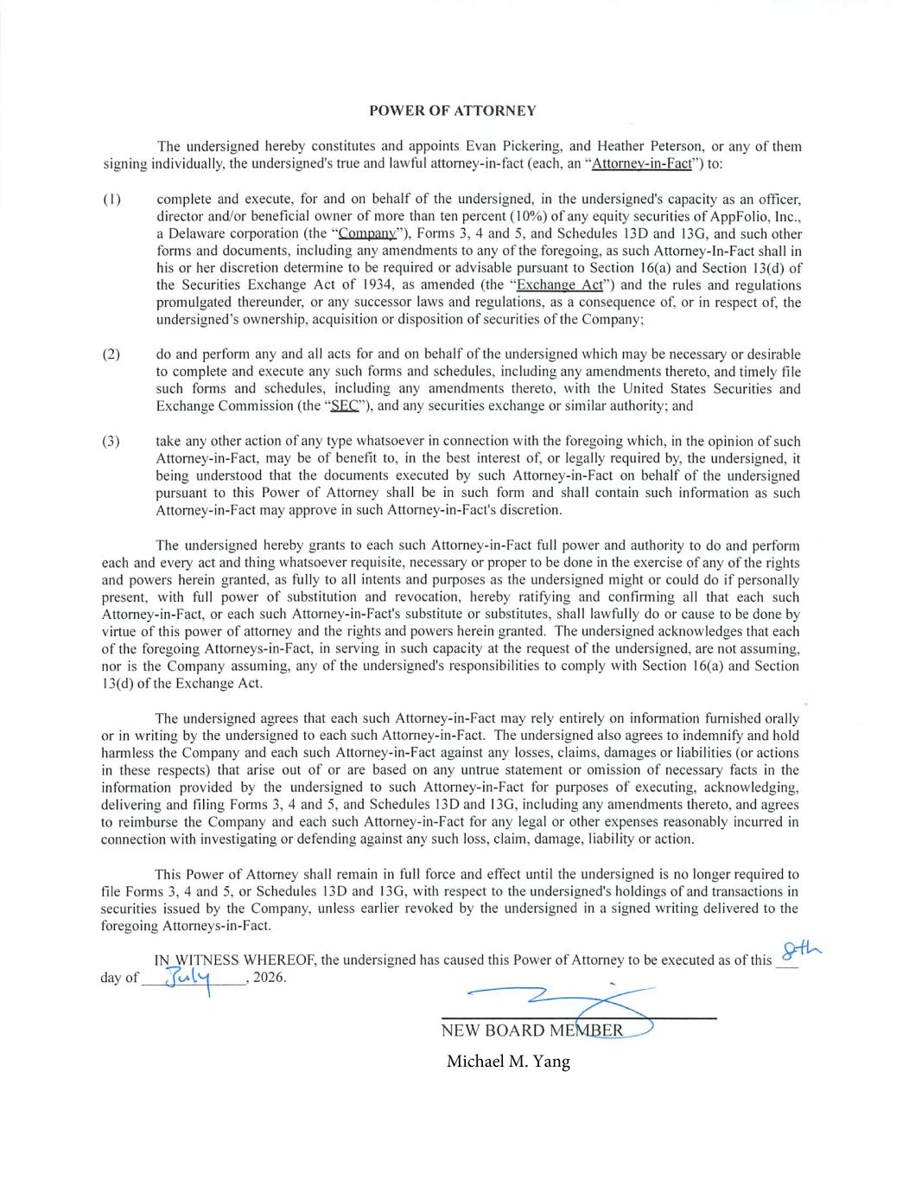
P O W E R O F A T T O R N E Y The undersigned hereby constitutes and appoints Evan Pickering, and Heather Peterson, or any of them signing individually, the undersigned's true and lawful attorney-in-fact (each, an "Attorney-in-Fact") to: (I) complete and execute, for and on behalf of the undersigned, in the undersigned's capacity as an officer, director and/or beneficial owner of more than ten percent (10%) ofany equity securities ofAppFolio, Inc., a Delaware corporation (the "CompanY"), Forms 3, 4 and 5, and Schedules 13D and 13G, and such other forms and documents, including any amendments to any ofthe foregoing, as such Attorney-In-Fact shall in his or her discretion determine to be required or advisable pursuant to Section 16(a) and Section 13(d) of the Securities Exchange Act of 1934, as amended (the "Exchange Act") and the rules and regulations promulgated thereunder, or any successor laws and regulations, as a consequence of, or in respect of, the undersigned's ownership, acquisition or disposition of securities of the Company; (2) do and perform any and all acts for and on behalf ofthe undersigned which may be necessary or desirable to complete and execute any such forms and schedules, including any amendments thereto, and timely file such forms and schedules, including any amendments thereto, with the United States Securities and Exchange Commission (the "E"), and any securities exchange or similar authority; and (3) take any other action ofany type whatsoever in connection with the foregoing which, in the opinion of such Attorney-in-Fact, may be of benefit to, in the best interest of, or legally required by, the undersigned, it being understood that the documents executed by such Attorney-in-Fact on behalf of the undersigned pursuant to this Power of Attorney shall be in such form and shall contain such information as such Attorney-in-Fact may approve in such Attorney-in-Fact's discretion. The undersigned hereby grants to each such Attorney-in-Fact full power and authority to do and perform 'each and every act and thing whatsoever requisite, necessary or proper to be done in the exercise ofany ofthe rights and powers herein granted, as fully to all intents and purposes as the undersigned might or could do if personally present, with full power of substitution and revocation, hereby ratif,'ing and confirming all that each such Attorney-in-Fact, or each such Attorney-in-Fact's substitute or substitutes, shall lawfully do or cause to be done by virtue of this power of attorney and the rights and powers herein granted. The undersigned acknowledges that each of the foregoing Attorneys-in-Fact, in serving in such capacity at the request of the undersigned, are not assuming, nor is the Company assuming, any of the undersigned's responsibilities to comply with Section 1 6(a) and Section 13(d) ofthe Exchange Act. The undersigned agrees that each such Attorney-in-Fact may rely entirely on information furnished orally or in writing by the undersigned to each such Attorney-in-Fact. The undersigned also agrees to indemnify and hold harmless the Company and each such Attorney-in-Fact against any losses, claims, damages or liabilities (or actions in these respects) that arise out of or are based on any untrue statement or omission of necessary facts in the information provided by the undersigned to such Attorney-in-Fact for purposes of executing, acknowledging, delivering and filing Forms 3, 4 and 5, and Schedules 13D and 13G, including any amendments thereto, and agrees to reimburse the Company and each such Attorney-in-Fact for any legal or other expenses reasonably incurred in connection with investigating or defending against any such loss, claim, damage, liability or action. This Power of Attorney shall remain in full force and effect until the undersigned is no longer required to file Forms 3, 4 and 5, or Schedules 13D and 13G, with respect to the undersigned's holdings ofand transactions in securities issued by the Company, unless earlier revoked by the undersigned in a signed writing delivered to the foregoing Attorneys-in-Fact. IN WITNESS WHEREOF, the undersigned has caused this Power ofAttorney to be executed as ofthis day of 3Lt'- , 2026. \ NEW BOARD MEMR&) Michael M. Yang

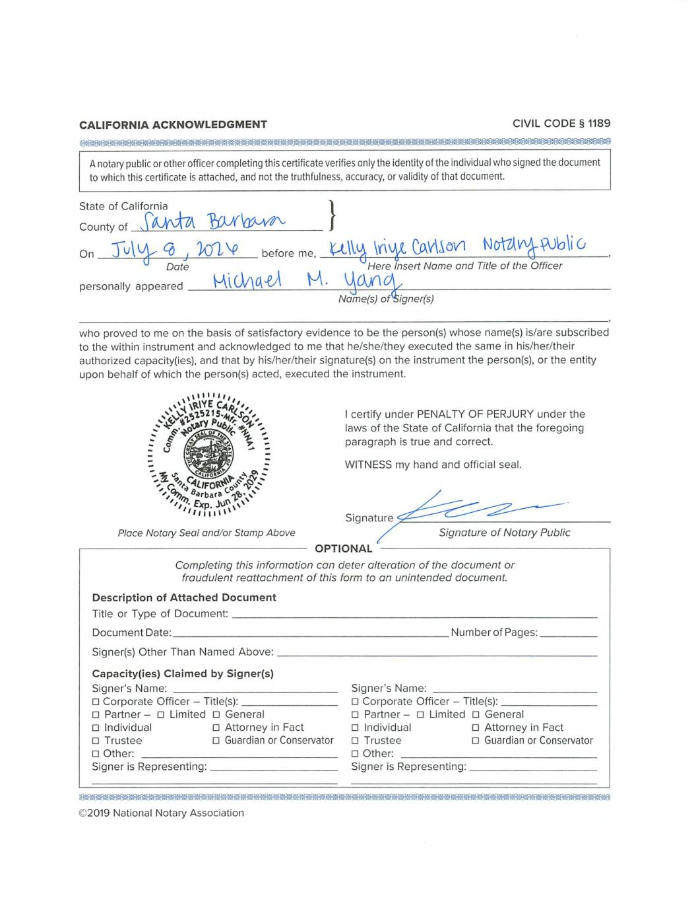
C A L I F O R N I A A C K N O W L E D G M E N T C I V I L C O D E § 1 1 8 9 A notary public or other officer completing this certificate verifies only the identity of the individual who signed the document to which this certificate is attached, and not the truthfulness, accuracy, or validity of that document. S t a t e o f C a l i f o r n i aC o u n t y o f } On J be fo re me , t \ \ Wü \zkvub \ I D a t e H e r e I n s e r t N a m e a n d T i t l e o f t h e O f fi c e r p e r s o n a l l y a p p e a r e d ' ' Name(s) of igner(s) who proved to me on the basis of satisfactory evidence to be the person(s) whose name(s) is/are subscribed to the within instrument and acknowledged to me that he/she/they executed the same in his/her/their authorized capacity(ies), and that by his/her/their signature(s) on the instrument the person(s), or the entity upon behalf of which the person(s) acted, executed the instrument. ; I I I ●:, , % 0 a r b a t . i % ' . ' I i , ; Place Notary Seal and/or Stamp Above I certify under PENALTY OF PERJURY under the laws of the State of California that the foregoing paragraph is true and correct. WITNESS my hand and official seal. Completing this information can deter alteration of the document or f r a u d u l e n t r e a t t a c h m e n t o f t h i s f o r m t o a n u n i n t e n d e d d o c u m e n t . Description of Attached Document Title or Type of Document: D o c u m e n t D a t e : Signer(s) Other Than Named Above: Capaci ty( ies) Claimed by Signer(s) Signer's Name: ____________________________ O Corporate Officer - Title(s): O P a r t n e r - O L i m i t e d O G e n e r a l O I n d i v i d u a l O A t t o r n e y i n F a c t O T r u s t e e O G u a r d i a n o r C o n s e r v a t o r O O t h e r : Signer is Representing: Number of Pages: Signer 's Name: ___________________________ O Corporate Officer - Title(s): O P a r t n e r - O L i m i t e d O G e n e r a l O I n d i v i d u a l O A t t o r n e y i n F a c t O T r u s t e e O G u a r d i a n o r C o n s e r v a t o r D O t h e r : Signer is Representing:

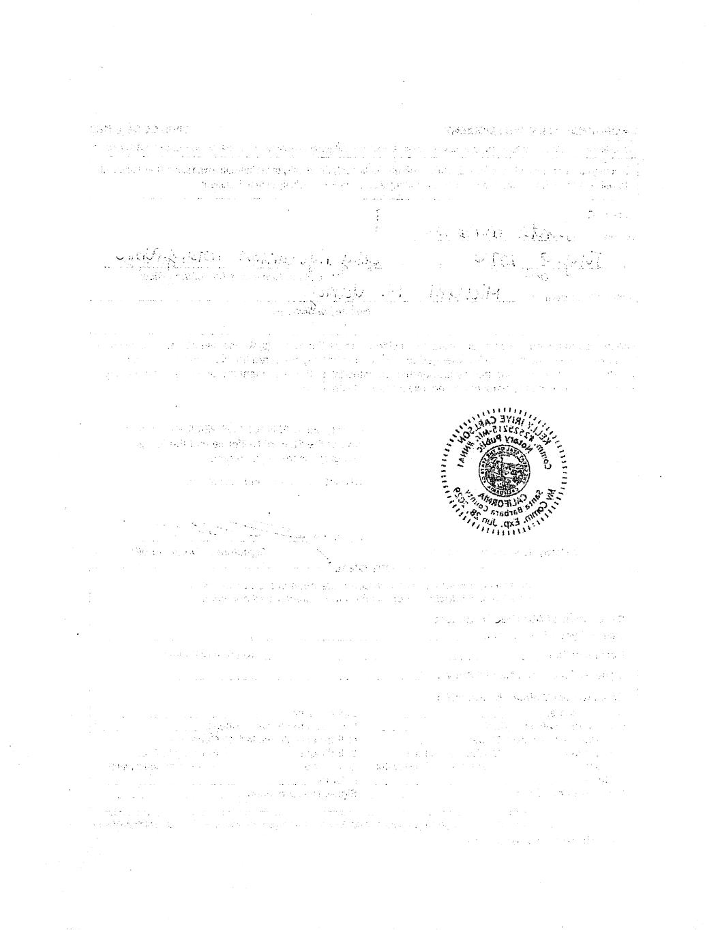
3 1 P ●:- r I - - ,

